**HAMZA SIRAJ**

Ward no. 8, House No. 18

Mohallah Rajgan P/O &

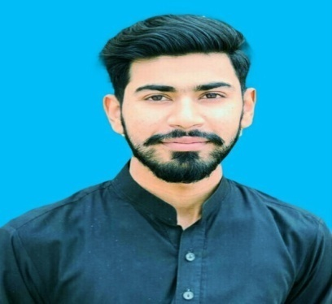Teh Gujar khan District RWP

Mobile no: 0305-5117975

E-Mail: hsprince43@gmail.com

CNIC# 37401-3172638-7

**Career Objective**

To be a part of an organization having fast growing prospects which complement and enhance my professional capabilities in the field of teaching and Administration.

**Personal Attributes**

Capable of assuming responsibility, exercising initiative, working independently and in teams;

Patient and diligent worker, quick learner with a sound grasping power; Makes the best out of my capabilities towards achievement of the Organizational Goals. Interested in intellectual pursuits as well as continued professional development.

**SUMMARY**

* Almost 2 years of practical experience in the field of Administration and Accounts.
* Master in commerce MCOM from university of Sargodha with1st Division.
* Reconciliations of all types including banks, debtor and creditors.
* Can do the verification of all transactions.
* Strong interpersonal skills with experience in managing and mentoring other staff members
* Excellent in analytical, administration and problem solving skills.

**AREAS OF EXPERTISE**

* Payroll worksheets
* Bank and Cash payment
* Bookkeeping
* Bank reconciliation statement
* Excellent communication skills
* Account payable and Receivable
* Asset management
* Advance MS excel
* Quick book software

**Professional Qualification**

* M.COM University of Sargodha 2020
* B.COM University of Punjab 2018
* FSC Rawalpindi Board 2015
* MATRIC Rawalpindi Board 2013

**Professional Experience**

* **Current employee of W Group of Industries (Accountant)**

1. Updating daily bank balances
2. Bank reconciliation statement
3. Preparation of payments
4. Petty cash management
5. Updating daily cash position statement
6. Bill posting after verification
7. Posting of bank receipts, payment and cash vouchers
8. Preparation and disbursement of salaries (Factory & Head office)

* **Worked at HBL (Cash officer)**

(12-4-2021 to 10-2-22)

1. Processing deposits and withdrawal
2. Cashing cheques
3. Making money transfer
4. Clearing cheques
5. Deal with bonds
6. Daily cash position
7. ATM Replenishment

* Two years’ experience in **Administration and Accounts** at Private College in Gujar Khan Rawalpindi

**General Interests and Talents**

* Exploring of books and people for widening the scope of my understanding towards life, transforming thoughts to sketches and words, internet browsing to keep up to date knowledge, playing Cricket and Badminton.

**Personal Data**

* Father’s Name: Siraj Ul Haq
* Date of Birth: 15-10-1996
* Nationality: Pakistani
* Languages: English, Urdu, Punjabi
* Religion: Islam
* Marital Status: Single