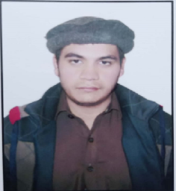

Summary:

An adaptable, proactive and enthusiastic student seeking a challenging job in order to work in a professional environment where my talent and capabilities can be refined, can be put into practical usage and further enhanced, for the benefit of the company/organization and possibly set to contribute for the growth of an organization.

Name: **HAMZA TARIQ**

Date of Birth: 24th AUGUST 1999

Address: HNO.224, STREET NO. 25,

SECTOR D-4, PHASE 1

HAYATABAD, PESHAWAR

TEL: 0331-9790684

Email: hamzatariqkhan9@gmail.com

* **Abasen university Peshawar** (From 2020 - Present)

Bachelors in B.S

Specialization: Electrical

* **Oriental degree college Peshawar** (From 2017 - 2019)

**F Sc:**

Specialization: Pre Engineering

Marks: (568 / 1100)

* **Working folks grammar school Hayatabad, Peshawar** (2017)

Matriculation in Science

Marks: (628 / 1100)

Educational Background

**Electrical Department** (From 2019 – 2022)

* Khyber Match Factory,
* Panel repair and maintenance.
* Single phase Fitting
* Contactor fittings(3 phase)
* 3 phase Wiring
* 3 Phase Panel Fittings
* 3 Phase Breaker Fitting
* Changeover system
* Manual to Automatic system
* Diagram Analysis
* **Certified with “CERTIFICATE OF APPRECIATION” as best student at Oriental Degree College**

WORK EXPERIENCE & ACHIEVEMENTS

COMMUNICATION & LANGUAGE

* **Communication**:
* Highly articulate in English communication with excellent presentation skills
* Fluent in Urdu
* Pashto

* **Technology :**

**MS OFFICE**

* Well-versed in PowerPoint, Word and Excel, good command on Computer’s Hardware & Software.

**INTERNET BASED MARKET RESEARCH**

* Good command of Windows Platform, Basic use of graphics applications like Photoshop, CorelDraw
* Excellent in Internet-based Marketing Research

COMPUTER EXPERIANCE

* Reference will be provided on demand