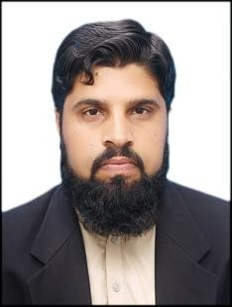

***RESIDENTIAL ADDRESS:***

***BAGH KORONA MASOOD KHIEL CHARSADDA***

**CONTACT: 0314-9088114**

# PERSONAL INFORMATION.

Name: Fazli Haleem

Father name: Fazli Aziz

Date of birth: 05/11/1995

Domicile: Charsadda

CNIC: 17101-3868866-3

email address: [fazlihaleemchd@gmail.com](mailto:fazlihaleemchd@gmail.com)

## OBJECTIVE.

My objective is to achieve excellence in a dynamic organization. I enjoy working as a part of an efficient team in friendly environment. I am capable of working on my own imitative in possess excellent organization abilities. I passes excellent communication skills and I am able to work under pressure to meet deadline. I always worked hard to achieve my goals.

***ACADEMIC INFORMATION.***

|  |  |  |  |  |  |
| --- | --- | --- | --- | --- | --- |
| **Examination** | **Year** | **Total marks** | **Obtained marks** | **Division** | **Board/ University** |
| S.S.C | 2013 | 1050 | 605 | 2nd | BISE Peshawar |
| F.CS | 2015 | 1100 | 613 | 2nd | BISE Peshawar |
| BS CS | 2019 | 4.0CGPA | 3.22CGPA | 1st | BKUC |

# COMPUTER SKILLS / OTHER SKILLS

|  |  |  |
| --- | --- | --- |
| * D.I.T | 1 year | From Technical Board Peshawar. |
| * General | 3 months | From Paradise Institute Of Information Technology |

**WORKING EXPERIENCE.**

* One year Government Contract on Communication and works Department (C&W).
* One Year of experience at Swabi Hotel as a Assistant Manager.
* Currently working as a( Admin & Receptionist ) at Marhaba Installment company

# LANGUAGES

* Pashto
* Urdu
* English