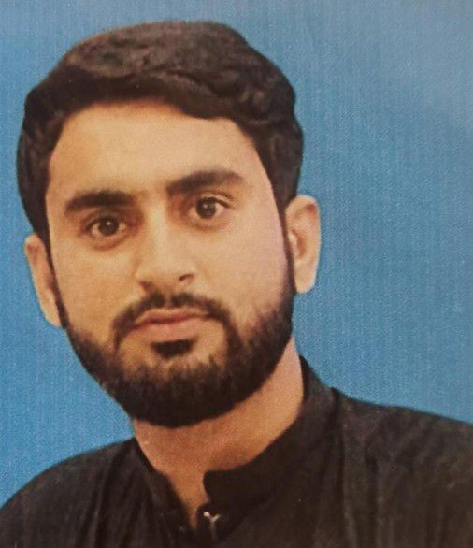

**Muhammad Farhan**

Email :- muhammadfarhankhan900@gmail.com

Mobile Number :- +**923152317850/+923089083736**

|  |  |  |
| --- | --- | --- |
| Objective | I believe human potential is at its best when it can handle any kind of pressure. I like to accept challenges.  I can always work to materialize new ideas in my career.  To do my level best to meet the requirements and standard of my organization.  I am always hardworking and ready to learn every news opportunity in any new environment. | |
| Experience | **RMI(Rehman Medical Institute)**   * **Designation: IT Support Engineer.** * **Company Name:** Rehman Medical Institute Peshawar * 2 years working as, a IT support Engineer. * **Primary Responsibilities:** * Software and hardware Support to RMI * Updating Bios, Software’s and Backup and restore data * Troubleshoot Hardware problems on Desktops and Laptops * Installation of operating system, Service packs and Driver software * Computer Software/ System application maintenance * Printer installation, sharing, and other required technical support   **Ufone PTML (Call Center Executive Islamabad)**  • Working as a Call Center Executive for assigned portfolio and new accounts.  • Maintaining an effective administration system.  • Rapidly responding to and resolving any Clint quires/ problems.  • Compliance issues.  • Coordinating office procedures.  • Making sure that information is quick and easy to locate.  • Offering a warm and friendly welcome to any visitors.  • Receiving and redirecting telephone calls.  • Managing electronic and printed files.  • Collaborated with management regarding new training procedures.  • Took part in Quality administration of Call Center.  • Applied and monitored adherence to standard call center operating procedures.  • Developed training programs for clients within call center  RELEVANT SKILLS, PERSONAL CHARACTERISTICS & BEHAVIOURS  • Possess excellent customer handling skills (Courtesy, Empathy, Active Listing)  • Sharp enough to up-sell and cross sell after determining customer’s need.  • Treat all customer queries with utmost courtesy and respect.  • Display strong work ethic and positive attitude.  • Possess good selling, convincing and negotiating skills.  • Good data handling skills.  • Proficient in relevant computer applications especially MS Office.  • Excellent interpersonal and communication skills to build Relationships with  Costumer  • Ability to work under pressure without supervision.  • Deal with difficult situation in friendly **manner.** | |
| Education |  | **2015** |
|  | **Matric ( SSC) –**  **Ceena Public School Pabbi.** | **2017** |
|  | **FSC:- (pre- Eng)**  **FG Degree College Nowshera.**  **BS(CS)**  **- AWKUM (SRH Campus pabbi.)** | **2022** |
| Skills | ➤ Capable of working on MS Office 2003/2007/2010/2013, 2016, 365. ➤ Good Typing Speed in Inpage ➤ Ability to adopt new skills. ➤ Ability to make good relation with Colleagues and Work force. ➤ Always keenly intended to work Hard Regular & with punctuality. | |

Additional Father Name :-

Information Muhammad Tariq

CNIC:-

17201-5270505-1

Martial Status:-

Married

•Domicile:-

Nowshera KPK

•Religion:-

Islam.

|  |  |  |
| --- | --- | --- |
| Interests | Reading Writing Games Hiking Study Seek interest in current affairs  Cricket Living in the Invention of something new |  |