

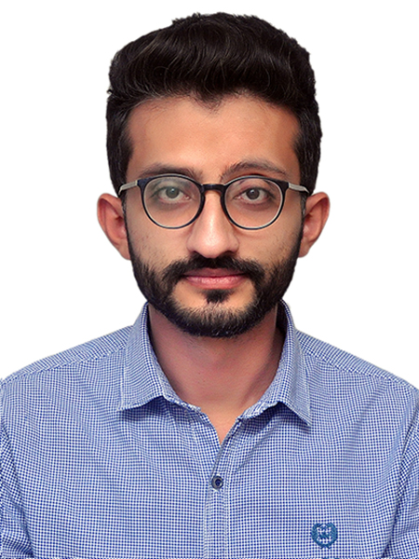

285-Q-BLOCK, MODEL TOWN EXTENSION LAHORE-54000



+92-300-7712819



[danishaslam281@gmail.com](mailto:danishaslam281@gmail.com)



DANISH ASLAM

**CAREER OBJECTIVE:**

Seeking a challenging position in dynamic & progressive mind organization where I can have a sense of Quality, Competition, Achievement and Recognition and to serve the organization with my utmost desire

# PERSONAL INFORMATION

CNIC: 33105-3326330-9

Marital Status: Single Domicile: T.T.Singh Religion: Islam Nationality: Pakistani

# EDUCATIONAL HISTORY

|  |  |  |  |
| --- | --- | --- | --- |
| **Degree** | **Year** | **Marks/CGPA** | **Board/University** |
| **BBA** | 2019 | 3.58/4.00 | Bahaudin Zikriya University |
| **FSc** | 2014 | 639/1100 | BISE, Faisalabad |
| **Matric** | 2011 | 805/1050 | BISE, Faisalabad |

**JOB EXPERIENCE**

HR & Purchase Officer LabCorp Diagnostic Center, Lahore

(March 2022 to Continue)

HR & Admin Officer Test Zone Diagnostic Center Lahore



‘(01-11-2018 to 28-02-2022)



# Educational Grip:

* Marketing Management
* Marketing Segmentation
* HR Management
* Administration
* Project Management
* Entrepreneurship
* Operation Management

# Admin & HR Experience/Abilities/Achievements:

* Turning Data into meaningful and actionable insights.
* Successful JV with Air-Blue & Test Zone for Covid-Rapid PCR at different airports in Pakistan
* Producing marketing and promotional materials
* Creating content providing [search engine optimization](https://www.thehartford.com/business-insurance/strategy/marketing-basics/search-engine-optimization)
* Producing internal communication
* Worked on ISO 9001:2015
* Conducting customer and [market research](https://www.thehartford.com/business-insurance/strategy/market-research)
* Overseeing outside vendors and agencies
* Able to make decisions with imperfect information.
* Producing innovative strategic ideas with clear objectives in mind.
* Relationship management with external agencies, vendor and business partners
* Managed end-to-end procurement process for various categories, including raw materials, packaging, and logistics.
* Negotiated contracts and terms with suppliers to ensure the best value for the company.
* Monitored and evaluated supplier performance to ensure compliance with contractual agreements.

# Extracurricular Activities:

* Nature Lover (Tourist)
* Football Player
* Basketball Player
* Seminar, workshops &

# References:

**Prof. Dr. M. Nauman Abbasi** Director SCM, BZU [nabasimna@bzu.edu.pk](mailto:nabasimna@bzu.edu.pk)



**Dr. Mr. Shahzad Akhtar** Assistant Professor, BZU [drshahzadakhtar@bzu.edu.pk](mailto:drshahzadakhtar@bzu.edu.pk)