**Curriculum Vitae**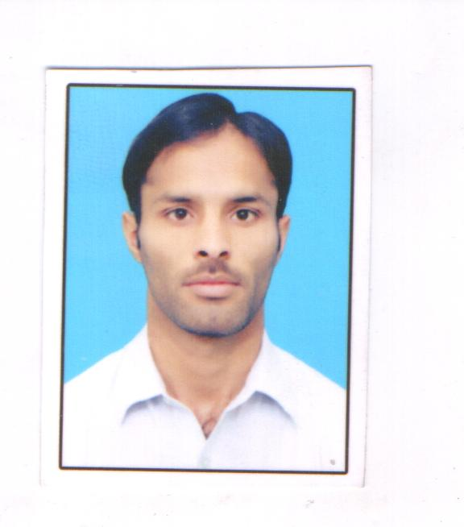

**HAFEEZ UR REHMAN**

**Contact No. 0331 9940915/0305 8630042**

**E-mail: hafeezafridi46@gmail.com**

|  |
| --- |
| **PERSONAL DETAILS** |

**Father Name : Fazal karim**

**Date of Birth : 1st Feb 1988**

**Gender : Male**

**CNIC No : 21202-1319389-7**

**Nationality : Pakistani**

**Religion : Islam**

**Marital status : Married**

**Domicile : Khyber District**

**Address : Jamrud Khyber**

**Postal Address : New abadi Mustajab ghari jamrud Khyber District.**

|  |  |  |  |  |
| --- | --- | --- | --- | --- |
| **Certificate / Degree** | **Session** | **Marks** | **Grade/Division** | **Board** |
| S.S.C (Science) | 2005 | 524/1050 | 2nd | BISE Peshawar |
| D.COM | 2008 | 862/1400 | 1ST | BTE Peshawar |
| B.COM | 2011 | 859/1400 | Ist | University of Peshawar |
| MS/MBA(3.5years)Finance | 2012/2015 | 2732/3500 | 1st | University of Peshawar |

|  |
| --- |
| **CAREER EXPERIENCE** |

2017-2018: Accountant : **AL HAJ STEEL FOUNDARY**.

2018-2019: Accountant: **BLACK GOLD STEEL MILLS**.

Nov 2019-Still Work : Accountant: **AFRIDI STEEL MILLS (PVT) LTD**.

**Major Responsibility**:

* Preparation and making entries to Ledgers and Journals .
* Tracking cash inflow and outflow of the Banks.
* Maintaining daily Bank balance.
* Presenting reports of cash flow of the bank to Management.
* Prepare Factory Monthly Profit & Loss Report and Balance Sheet .
* Prepare Monthly employees payroll sheet.

|  |
| --- |
| **COMPUTER SKILLS** |

* Work on Company Software ( MSK Financials –POS ).
* Office Automation Certificate (6 months)
* Internet surfing

|  |
| --- |
| **LANGUAGES KNOWN** |

**Language Speaking Reading Writing**

* Urdu Excellent Excellent Excellent
* Pushto Excellent Excellent Excellent
* English Good Excellent Excellent