Talib Hussain
Contact No: 0300-9697162, 0336-9697162 
E-Mail: talib_hussain77@yahoo.com

Present Address: House # 8 Shadab Colony Chung Lahore

Permanent Address: House # 42 Executive Block Jeewan City Phase 1 Sahiwal

___________________________________________________________________________________________

Career Objective:
“To be a part of an institution that would fully employ my personal skills as well as my academic training in a rewarding career that afford professional and personal growth”.

Personal Profile:
Father’s Name: Nazir Hussain
Date of Birth: April 04-1977
Religion: Islam
Nationality: Pakistani
CNIC#: 36101-0244271-7
Marital Status: Married

Educational Record:

Qualification Institute
B.Com B Z U Multan
D.Com Punjab Board of Technical Education Lahore
Matriculation Board of intermediate & secondary education Multan
Diploma Certificate Computer Application & Office Professional

Professional Skills:

- 

SAP ERP software an integrated solution that incorporates the key business functions.
Training of SAP ERP Ecc 6.0 ver material Management major working areas as purchasing, Inventory & invoicing.
Operational management of Supply chain Logistics & Warehousing project.

Order Management
Sale Coordination
Distribution center Management
Transportation Management
SAP Ware House Management
Inventory Management
Ware House Management
Supply Chain Management
Freight Management
Vendor Coordination
Vendor Management Skills
Data Management
Communication Skills
Proficient in MS Office
Internet surfing, Email

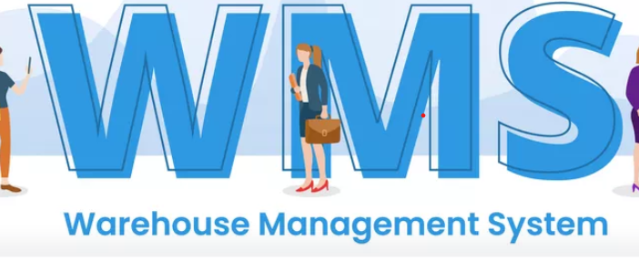

Also working on WMS in a Company and have experience. WMS integrated with SAP.

Scanning
Inbound
Outbound
Stock Take
OGP & IGP
Barcode System
Inventory
Consignments.

Experience:

- 5 years in Haier Pakistan as a Assistant Manager Warehouse &Logistics (Continue)
- 1 year in TCL Electronics as a Supply chain Executive.
- 6 Years in Orient (Samsung) as a Sr. Officer Finished Goods Warehouse & Logistics.
- 1 year in Hussain Mills as an Assistant Procurement Officer.




- Presently Working in Haier Pakistan (Pvt) Ltd as Assistant Manager Warehouse &Logistics.
- Sales Coordinator, Ware House Management.
- Inventory Management, Inbound/Outbound operations.
- Logistics planning and to oversee the day-to-day operational activities of plant central Distribution center area 300000 SQ FT”.
- Planning, organizing and controlling of over-all distribution operations nationwide.
- Responsible for coordination with sales team (National Sales Manager, ZSM & BMS) all over country wide.
- Dispatch order planning & execution for countrywide branches & direct distribution channels.
- Ensure that orders are picked and shipped timely and within prescribed KPIs.
- Manage stock control, the self-assured receipt, storage, retrieval and timely delivery of goods, shipment unloading & transferring.
- Documents recording and data entry into ERP system (SAP Warehouse Management System).
- Responsible for managing resources (material handling equipment and 100 manpower) required for day-to-day warehouse & distribution operations.
- Implementation of all operational SOPs and ensure compliance.
- Analyzing all warehouse personnel and activates on a frequent basis including receiving, put away, replenishment, quality checking, loading and shipping.
- Ensure stack the material in FIFO method.
- Ensure current & accurate inventory control.
- Identify training needs for all operational staff and arrange training.
- Monitor and improve facility, Safety, Security, Environmental, Quality standards through SOPs and inspections.
- Preparations of SAP work Instructions.
- Vendor Management, price negotiation for best supplies, support & services for the operations.
- Responsible for liaison with all suppliers (transport and labor contractor for day to day operation concerns).
- Receives finish goods from production and as well imported shipments.
- Areas worked upon MM/SD
- Stock Transport Request
- Stock Transport Order
- Out ward Gate Pass
- Goods Receipt Note
- Delivery Orders
- Finished Ware House Location Control
- Batch Management for all locations
- Control all branches ware houses activities
- Control Freight Module though SAP in H.O and Branches

Extra Curricular Activities:

- Reading Books, Playing cricket, badminton.

Reference:

Will be furnished on demand.

