# OBJECTIVE :

To get real experience through an active practice combined with technical knowledge with the intentions to improve my self and to become an increasingly important assets for the organization.

# EDUCATION:

SHEHROZ KHAN

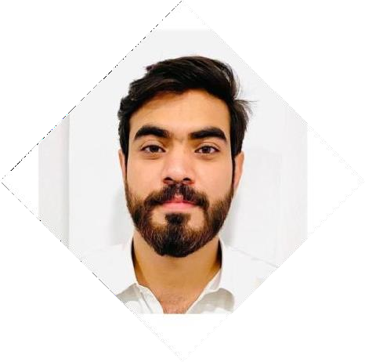

S/o Sameen Jan

**Personal Information**

### Birth Date

24th April 2002

### Gender

Male

CNIC No.

17301-8315701-9

### Residence

House No. 302, Street 7, Sector, P-2, Phase 4, Hayatabad, Peshawar.

### Contact:

+92-314-9949944

### Email:

[Shehrozkhan3115@gmail.com](mailto:Shehrozkhan3115@gmail.com)

war

# WORK EXPERIENCE:

|  |  |  |  |
| --- | --- | --- | --- |
| • | **2023** | **BBA Hons** | **B** |
| • | **2019** | IMS University of  **HSSC**  BISE Peshawar | Pesha  **B** |
| • | **2017** | **SSC** | **A** |
|  |  | BISE Peshawar |  |

.

* BSC at State Life Insurance Corporation of Pakistan Since 01-September-2023 till Date .

# LANGUAGES:

* English
* Urdu
* Pashto

# COMPUTER SKILLS:

* + MS Office
  + MS Word, Excel, Power point, Access
  + Internet Surfing

## CERTIFICATIONS

* Six weeks of Internship in United Bank Limited (UBL) Building Branch (0059) Phase 5, Hayatabad Peshawar.

(27-06-2022 to 07-08-2022)

* Six weeks of Internship at National Database and Registration Authority NADRA

(17-07-2023 to 28-08-2023)