AWAIS NOOR
cell phone:+92 3218485633
E-mail:awaisnoor7@gmail.com
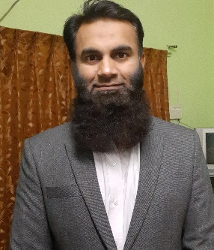
Objective& Strengths
Objective
To take-up challenging tasks in professional organization to contribute my talent and potential positively in the process and growth of the organization and be a role model in the profession.
Strengths
Highly motivated and diligent individual with an academic background combined with leadership and involvement in community. Enthusiastic and outgoing personality with a desire for undertaking responsibility, Commitment to continuous learning and a desire to set and achieve goals. Relevant professional qualification and experience.
Education
MBA (Marketing) UCP,Lahore 2007

BSc(Computer Science) BZU, Multan 2005

FSc(Math,Physics,Chemistry). BISE, Multan 2002

Matriculation FBISE Islamabad 2000

Summary of PROFESSIONAL EXPERIENCE
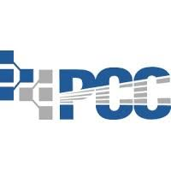
PAKISTAN CONSTRUCTION CHEMICALS
Assistant Sales Manager
May 2021 - Present
- Looking after sales of construction chemicals in southern Punjab
- Looking after retail market, industry and construction projects.
- Meeting and educating end users about the products.
- Meeting sales and recovery target on monthly basis.

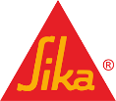
SIKA PAKISTAN
Sales Engineer
April 2017-May 2021
- Looking after sales in south Punjab.
- Responsible for achieving monthly sales target.
- Opening new retailers to increase market penetration.
- Visiting industry and mega projects for construction chemicals.


ICI PAKISTAN LTD.
Assistant Sales Manager
May 2014-April 2017

- Responsible for fulfilling company’s sales objectives of Adhesives in Lahore, Multan, Faisalabad, Sahiwal and Sargodha Territories.
- Management of Sales staff to ensure effective shelf movement in retail market and at distributor’s end.
- Responsible for obtaining the monthly forecasting data after critically analyzing monthly market trends.
- Analysis of Sales performance of each sales person and updating performance of each sales person to RSM
- Working with RSM on requirement of promotional materials and proposals of promotional activities and making appropriate arrangements
- Ensuring off takes, deliveries and payments from market in order to facilitate distributor operations in Lahore, Faisalabad, Multan and Sargodha
- Gathering market intelligence and updating RSM/BDM regarding price increase/decrease and promotional activities of competitors
- Implement Health, Safety and Environment policies and procedures and further delivering the message to sales team.
ICI PAKISTAN LTD.
Sales Promoter (Central region)
Mar 2008-May 2014

- Did accurate forecasting of Adhesive business for smooth operational process.
- Kept management up to date regarding low tier and high tier adhesive products (Wood Glue and Paint Acrylics) by continuous market research.
- Accomplished territorial sales human resource objectives by recruiting, selecting, orienting, training, assigning, scheduling, coaching, counseling, and disciplining employees in assigned districts; communicating job expectations; planning, monitoring, appraising, and reviewing job contributions; planning and reviewing compensation actions; enforcing policies and procedures.
- Achieves territorial sales operational objectives by contributing territorial sales information and recommendations to strategic plans and reviews; preparing and completing action plans; implementing production, productivity, quality, and customer-service standards; resolving problems; completing audits; identifying trends; determining regional sales system improvements; implementing change.
- Met territorial sales financial objectives by forecasting requirements; preparing an annual budget; scheduling expenditures; analyzing variances; initiating corrective actions.

Language
- English
- Urdu
- Punjabi
- Arabic
Reference
Educational and professional references will be furnished on demand.

