SAFDAR ALI 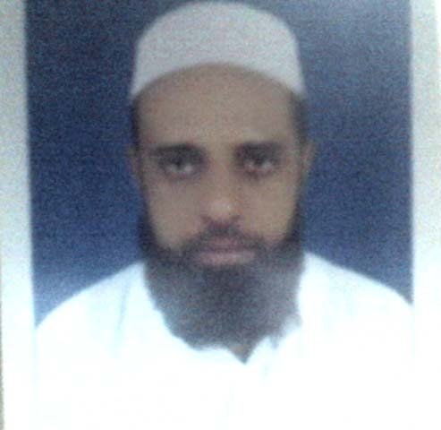

Father’s name: - Akbar Ali Khan
Date of birth: - 10th of April 1981
Permanent Address: - Village & P.O. Teri, Tehsil Banda Daud Shah,
District Karak N.W.F.P.
Mobile No: - 0346-9295453
E-mail:- safdarteri@yahoo.com

MY OBJECTIVE
My objective is to serve the organization with the best of the expertise in the field of Import, Finance & Accounting. And enthusiastically seeking experience in the field of Import, finance & Accounting.

EXPERIENCES
- AZAN TRADING COMPANY (IMPORT MANAGER)
Currently Working as an Import Manager in AZAN TRADING COMPANY I-9, Industrial Area Islamabad from March, 2015.

- Lot of experience in field of import.
- Sales Tax Calculation of Scrap items.
- Bank Dealing for LC opening (Letter of Credit) And Contract opening, CAD/DP documents or DA Documents or Open Documents etc.
- Electronic Import Form on weboc (EIF) (lc or cad or open)
- Documents handling of BL (bill of lading) and GD (goods declaration.
- PSW (Pakistan Single Window).
- Bank T.Ts against open import documents.
- Shipping lines dealing and clearing agents.
- Costing of Scrap after clearing from Port.
- Stock maintaining and reporting.
- Calculation and checking of duties and expenses paid by the clearing agent at port.
- Reconciliation of Bank Statements and parties statements.
- Recording entries manually & computerized using Accounting Software QUICK BOOKS.

- OGDCL

Experience in the Base Workshop of OGDCL I-9, Islamabad as part time in the account section for one month. Working there, I get more information about the accounting system of such type of big government organization of oil & gas sector.

- Cash Payment Voucher.
- Bank Payment Voucher.
- Withholding Tax.
- Recording of accounting entries.

- SIDDIQUI GROUP OF INDUSTRIES(S.G.I)
Working experience as an Accountant in SIDDIQUI STEEL FURNACE, I-9, Industrial Area Islamabad.

- Statement Reconciliation of Banks and Parties.
- Recording Journal entries manually & computerized.
- Maintenance of Cash Book, Expense Ledger & Party Ledger manually & computerized using Accounting Software.
- Vouchers checking
- Daily comparison between manual & computerized record.
- Cash deposits in Banks, Cash of Cheques and Transfer of Cheques.
- Comparison of physically stock with records.

- S.H Steel Mills And S. H Furnace
Six year experience as an Accountant in S.H Steel Re-rolling Mills, I-9, Industrial Area Islamabad.

- Reconciliation of Bank Statements and Parties Statements.
- Recording Journal entries manually & computerized.
- Maintenance of Expense Ledger, Party Ledger, Bank Ledgers and Cash Book manually & computerized using Accounting Software.
- Checking of bill books.
- Banks dealing and Other Administrative tasks.

QUALIFICATION DIVISION UNIVERSITY/BOARD
MBA (FINANCE) 1st KUST, kohat.
B.A. 2nd Peshawar University.
F.A (INTER SCIENCE) 2nd BISE Peshawar.
S.S.C 2nd BISE Peshawar.

INTERNSHIP
I did my Internship at National Bank of Pakistan, Main Branch Kohat from Dec 2004 to Jan 2005. While working here in, I learnt how to work in a diverse working environment.
- Account Opening
- Current Account and Saving or Profit & Loss Account
- Cheque Books Issuing
- Ledger Maintenance
- Remittances, Foreign Exchange & Bill Section
- Clearing Section
- Advance Section

LANGUAGES
- ENGLISH
- URDU
- PUSHTO.

COURSE & CERTIFICATION
Basic Computer course from Sun Rising Computer’s
- Windows, Ms-Word/ Ms-Excel.
- Ms-Power Point.
- Ms-Access
- Internet
- Good skill of typing

