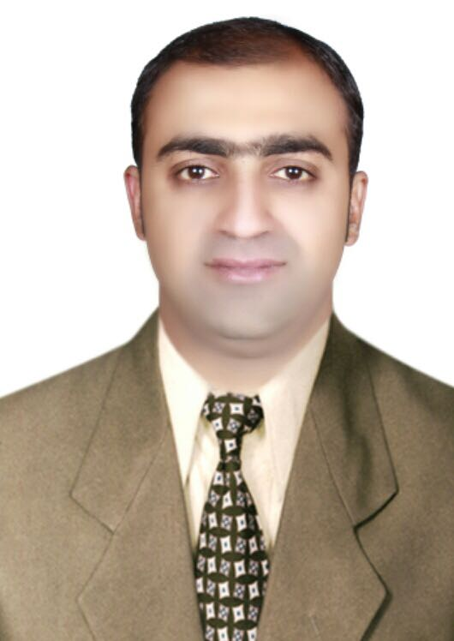**Qasim Muqeet Parvez**

**Cell # 0333-9867790**

**E-mail:** [**qesim.awan@gmail.com**](mailto:qesim.awan@gmail.com)

**Address: H-No 13, Sardar Hussain Road CMH Chowk, Kohat Cantt.**

**PROFESSIONAL SYNOPSIS**

* Management skills having around **1 years** of experience in sales and marketing in electronics group & Kitchen Appliances Companies in Pakistan namely, Ruba Digital & Axle Appliances.
* Management skills having around **1 Year** of experience and so on in sales and marketing in Automobile Industry Company in Kohat namely Prince Kohat Motors. 3s Dealers of Regal Automobile
* An excellent planner with proven abilities in accelerating growth in sales, generating customer loyalty levels and serving distribution network and corporate sector customers effectively.

**KEY STRENGTHS**

* Able to make rapid assessments and ensure progress with good achievement.
* Ability to perform well on both independent contributor and team member

**AREAS OF EXPERTISE & EXPOSURE**

**Sales & Service Operations**

* Drive sales initiatives and for strategic market positioning.
* Ensure territorial growth/development for increasing sales volumes.
* Map & analyze business potential, identify new profitable product & product lines.
* Identify and explore new markets and tap profitable business opportunities for business development.
* Businesses prospecting of complete range of products.
* Designing and conducting pre-sales presentations to the potential company distributors.
* Build a harmonious relationship with bulk consumers and corporate key accounts.

**CAREER HIGHLIGHTS**

**September 2021 – Till Now**

**Organization: Galaxy Appliances**

**Department: Sales and Marketing**

**Designation: Sales Executive**

***ORGANIZATIONAL PROFILE***

Galaxy Appliances is one of the best consumer electronic company in Pakistan which offer high end quality product in consumer electronics. And it’s also a member company of Berkeley Group UAE.

***RESPONSIBILITIES***

* Promoted Galaxy Product.
* Generating sales revenue.
* Plan and conduct direct marketing activities to promote sales.
* Maintain daily activity report.

**January 2019 – March 2020**

**Organization: Prince Kohat Motors**

**Department: Sales and Marketing**

**Designation: Sales Executive**

***ORGANIZATIONAL PROFILE***

Prince Kohat Motor 3s Dealer of Regal Automobile is one of the fastest growing Automobile Showroom in Kohat which offer Sales, Service, Spare Parts

***RESPONSIBILITIES***

* Promoted Prince Cars.
* Generating sales revenue.
* Plan and conduct direct marketing activities to promote sales.
* Prepare and present sales contract to Customer
* Preparing Bank financing plan for a customer
* Maintain sales activity records and prepare sales reports.

**July 2018 – January 2019**

**Organization: Axle Appliances**

**Department: Sales and Marketing**

**Designation: Sales Executive**

***ORGANIZATIONAL PROFILE***

Axle Appliances is one of the fastest growing Home Appliances Company in Pakistan which offer home appliances, Kitchen Appliances, products solutions.

***RESPONSIBILITIES***

* Promoted Axle Products.
* Generating sales revenue.
* Plan and conduct direct marketing activities to promote sales.
* Prepare and present sales contract to dealer.
* Maintain sales activity records and prepare sales reports.

**March 2017 – July 2018**

**Organization: Ruba Digital Pvt.Ltd**

**Department: Sales and Marketing**

**Designation: Sales Executive**

***ORGANIZATIONAL PROFILE***

Ruba Digital is one of the fastest growing electronic retail chain networks in Pakistan which offer sits customers a wide range of the finest consumer electronics: kitchen & home appliances, power solution, mobiles/IT related products and lighting solutions, with the option to Buy Now and Pay Later.

***RESPONSIBILITIES***

* Promoted Ruba Products.
* Generate sales on daily basis
* Order execution
* Ensure recoveries on regular basis.
* Reporting to all concerned
* Push Sales

**ACHIEVEMENT**

* Doubled sales per representative
* Achieved the targets in all months
* Achieved the sales in diversified products (AC, Fridge, Freezers, LCD, and LED etc.)

**ACADEMIC CREDENTIALS**

* Bachelor of Arts, Al-Kher University, (2016)
* D.Com – Accounting, BTE Peshawar KPK, Pakistan (2010)

**Computer Skill**

* 1 Year Diploma in Information Technology, Skill Development Council, Peshawar (2010)
* 3 Months Diploma in AutoCAD 2d/3d, Skill Development Council, Peshawar (2010)
* IOSH Diploma in Health & Safety, Institute of Safety & Health, United Kingdom, (2014)

**INTERPERSONAL SKILLS**

* Good team leader.
* Flexible enough to adopt changes
* Good Management Skills
* Believe in professional growth.
* Excellent communication skills.
* Customer Relations
* Sales Management
* Marketing Skills
* MS Word, Excel, Power Point.

**PERSONAL DETAILS**

* Father Name: Khalid Parvez
* Nationality: Pakistani
* CNIC: 14301-5711484-7
* Religion: Islam
* Marital Status: Married
* Date of birth 12-12-1991

**References**

Reference to be furnished on Request