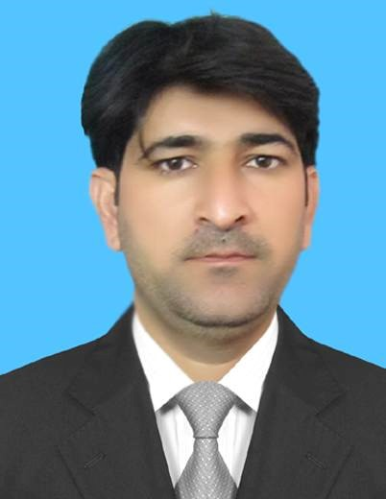 |  |  | About Me  Accomplished finance professional with a proven track record at Nabizada Wardak Construction Company, enhancing cash flow management and fostering strong client relationships. Expert in accounting software and internal auditing, with exceptional multitasking abilities. Achieved consistent client satisfaction and financial accuracy, driving business growth and operational efficiency.  Professional Experience  Accounts Officer  Afridi Medical Complex  Peshawar, Khyber Pakhtunkhwa, Pakistan  - Communicated and resolved disputes with clients regarding outstanding invoices, payments and adjustments.  - Updated general ledger of accounts with current, accurate and industry-compliant data to meet all internal and external audit requirements.  - Overhauled process for year-end inventory audits to improve accuracy.  - Developed strong relationships with external partners such as banks and vendors to facilitate smooth transaction processing on behalf of the company.  - Input vendor payments and updated accounts to reflect new balances.  - Supported month-end closing process by preparing comprehensive journal entries and adjusting balances as necessary.  - Collaborated with purchasing department to reconcile vendor invoices and facilitate payments.  - Reduced discrepancies in financial statements through meticulous data entry and record-keeping practices.  - Prepared detailed financial reports for senior management review, highlighting key performance indicators and trends impacting business health.  Manager  Link International Currency Exchange Pvt Ltd.  Peshawar, Khyber Pakhtunkhwa, Pakistan  - Improved customer satisfaction ratings by enhancing service quality and resolving client issues promptly.  - Maintained friendly and professional customer interactions.  - Continuously monitored branch performance against key performance indicators, taking corrective actions as needed to ensure objectives were met or exceeded.  - Implemented effective sales strategies to achieve branch targets and exceed expectations consistently.  Finance Manager  Nabizada Wardak Construction Company  Kabul Afghanistan  - Strengthened internal controls through regular audits and adherence to regulatory requirements.  - Trained new and existing staff members in various financial procedures to prepare for job requirements.  - Prepared monthly reconciliation of bank accounts and took corrective actions on deviations.  - Processed invoices and contacted appropriate parties for timely payment receipt.  - Developed comprehensive financial reports for executive decision-making support.  - Mentored junior finance staff, fostering professional development and strong team dynamics.  - Optimized cash flow management, allowing for timely investment and debt reduction.  Account Manager  Nabizada Wardak Construction Company  Herat Afghanistan (19KM Road Project)  Imame Shashnoor Road Project  CLIENT: NRAP  - Increased client satisfaction by building strong relationships and addressing their needs promptly.  - Successfully resolved escalated issues, preventing potential loss of valuable clients while maintaining positive relationships with all parties involved  - Conducted regular account reviews to identify areas for improvement and ensure continued success.  - Established clear communication channels between clients and internal teams, ensuring seamless project execution.  - Negotiated contract terms with clients, securing favorable agreements for both parties.  Accounts Manager  Nabizada Wardak Construction Company  Doshi to Polehomri Road Project 52KM  ClienT: I.D. B (Islamic Development Bank)  - Trained junior account managers in best practices and industry standards, fostering a high-performing team culture.  - Managed a diverse portfolio of accounts, demonstrating adaptability across various industries and client needs.  - Implemented efficient billing procedures to reduce outstanding receivables and improve cash flow.  - Collaborated with purchasing department to reconcile vendor invoices and facilitate payments.  - Optimized internal communication between departments to address client inquiries efficiently and accurately.  - Conducted regular account reviews with clients, providing valuable insights into performance metrics and recommending actions for improvement.  - Developed comprehensive financial reports for stakeholders, ensuring transparency and informed decision making.

SHAH FAISAL

My Contacts

 | Tehkal Payan Peshawar  25120
 | 0092-3117575283
 | Faisallink238@gmail.com
 | hodfinance@afridimedicalcomplex.com
Education Background
MBA (Finance)
IBMS/CS Agriculture University Peshawar KPK.

MSc (Economics)
University of Peshawar, KPK.

B.Sc (Pre Medical)
Govt Collge Peshawar
University of Peshawar KPK.

F.Sc (Pre Medical)
Govt Collge Peshawar
University of Peshawar KPK.

SSC (Science)
Peshawar Board KPK.

DIT (Information Technology)
Board Of technical Education KPK.

Professional Skills
Accounts receivable and payable
General ledger entry
Internal Auditing
Invoice Processing
Bank Reconciliation
Funds reconciliation
Bookkeeping
Accounting Software Proficiency
Cash Flow Management
Payroll Processing
Multitasking Abilities
Excellent Communication

Languages Proficiency
Urdu: - Speaking: Fluent Reading Fluent Writing Fluent Understanding Fluent
English: - Speaking Fluent Reading: Fluent Writing: Fluent Understanding: Fluent
Persian: - Speaking: Fluent Reading: Proficient Writing: Proficient Understanding: Fluent
Pashto: - Speaking: Proficient Reading: Basic Writing: Basic Understanding: Proficient
Hard Skill
Financial Analysis ,Financial Planning & Forecasting Risk Management,Financial Reporting Auditing & Compliance
Soft Skill
Communication, Adaptability
Collaboration Problem-Solving

