KAMRAN HAMAYUN
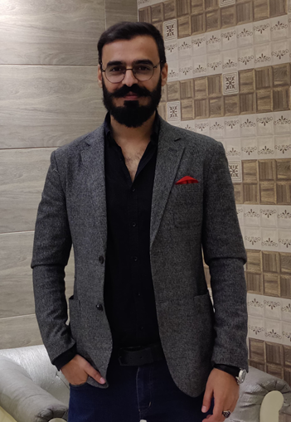

Experience
2021–2022
Intern • Kakakhel Law Associates
( I worked on Legal Research in finding judgments of Apex Courts to help in our cases. Drafted Legal Notices, Contracts, Plaints, Written Statements. Handling of clients by answering their queries and updating them on their cases.)
2022–2024
Associate • Dream Law Firm
( Helping the firm in courts by arguing our cases. Management of case files and labelling. Legal research of case laws from the August supreme court and finding precedents. Handling of clients.)
2022–2026
-- Local Youth Councilor NC-93 Hayatabad • Election Commission of Pakistan
( Part of the Arbitration Committee ( having a role of de-escalating marital disputes between parties )
-- Member of the Police Liaison Committee. ( giving opinion on social problems faced in our district and how to manage them to Police officials.
-- Organizing tournaments for the youth i.e Hayatabad Futsal League.

Education
Beacon House School, Peshawar FC Campus ( O and A levels ) (2010 – 2015 )
Edwardes Colleges Peshawar ( B.A ) ( 2015-2017 )
Islamia Law College Peshawar ( LLb ) ( 2018-2021 )

Certificates
Khyber Pakhtunkhwa Bar Council Association. (2022 )
Peshawar Bar Association. ( 2022 )
Ambassador of WWF ( 2012 )

Skills
Proficient in Ms-Word
Legal Drafting of miscellaneous documents.
Report Writing
Criminal Law

Hobbies
Chess, Football, Console Gaming.

Languages
English – Expert
Pastho – Expert
Urdu – Intermediate
Persian and Punjabi – Beginner

H#340, St#7, Sec E4, Hayatabad Peshawar

03369124094
kamran.marwat094@gmail.com

