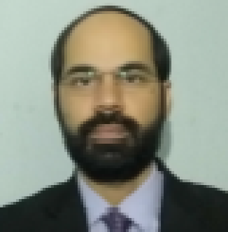 ADDRESS: H # 335, Block F, Al Rehman,

Garden Phase II Lahore

Cell: 0321-4548602

E-mail: [zee.chugtai83@gmail.com](mailto:zee.chugtai83@gmail.com)

**Zeeshan Pervaiz**

**OBJECTIVE**

To pursue a career in a progressive organization that provides opportunities for career growth and professional development in order to room overall personality and to work in excellent and challenging environment with the team of experts

**EDUCATION**

* **MBA Professional (Master of Business Administration):** **2010**

Minhaj University Lahore, Gulberg Campus

Major: Specialization **(Finance)** CGPA:**3.43**

* **B. Com (Bachelor of Commerce):**  **2005**

Govt Islamia College of Commerce,

Major: Commerce

* **F.Sc (Science):**  **2003**

Govt Science College , Lahore

* **Maticulation (Science):**  **2001**

BISE, Lahore

* **Specialization of Major Subjects during MBA:**
* International Finance
* Investment & Portfolio
* Auditing
* Financial Analysis
* **Major Projects during MBA:**
* Project on Financial Analysis
* Project on Deficit Budget
* Project on E. Commerce
* Research on Nokia Mobiles.

**EXPERIENCE**

**ACCOUNTS OFFICER LAHORE GYMKHANA CLUB (18 FEB, 2012 TO -Present-)**

* Checking of Goods Receipt Notes
* Posting of Journal Voucher’s, i.e Expenses that are incurred into the multiple department of the Club
* Reporting to the Finance Manager, about all type of expenses that are incurred on daily basis
* Reconciliation of Venders / Account Payable Ledgers
* Posting of Journal Voucher’s of Petty Cash Expenses of multiple departments in the Club
* Preparation of Final Report of Scrap List on Excel of all the Departments of the Club

**ACCOUNTS EXECUTIVE UZAIR HAMMAD FAISAL & CO. (May 17, 2008 To 31 Mar, 2011)**

**(Chartered Accountants)**

* Creating and processing invoices
* Cross - checking invoices with payments and expenses to ensure accuracy
* Managing company’s account payable and receivable
* Sending bills and invoices to client
* Communicate with clients regarding billing and payments

**ACCOUNTANT MEDIPAK LIMITED (19 JAN, 2007 TO 24 APR, 2008)**

* Preparation of Invoices in FoxPro Accounting Software
* Summarizing of Account Receivable Status
* Summarizing of Daily Cash and Cheques Collection Report
* Summarizing of Sales Report on Daily Basis

**ACCOUNTANT K.E PRIVATE LIMITED (05 JAN, 2006 TO 30 OCT, 2006)**

* Preparation of Staff Salaries
* Preparation of Invoices
* Preparation of Expenses Ledgers
* Preparation of Profit and Loss Report

**CERTIFICATE / COMPUTER SKILLS**

* Computer Typing Speed: 60 (WPM)
* Diploma of Microsoft Office: University of the Punjab (Haillay College)
* Diploma of Peachtree Accounting: ICMAP
* Command on Business Management System, FoxPro, and Quick Books

**REFERENCE**

Will be Furnished on Demand