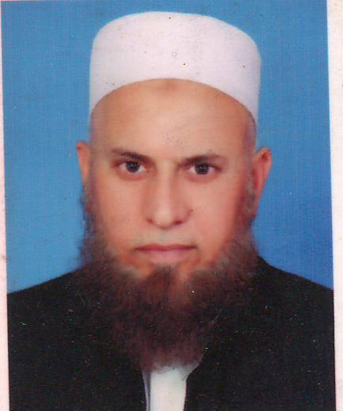**CURRICULUM VITAE**

**ABDUL HALIM**

**(Retired Havildar (Clerk) From Pak Army)**

**(A.S.C)**

**CAREER OBJECTIVE**

To obtain a challenging position in a reputed organization where I can utilize my experience and knowledge with commitment and dedication.

**PERSOAL DOSSIER:**

Father Name : Pasham Gul (Late)

CNIC No : 14202-1312158-5

Date of Birth : 22 May 1965

**TEMPORARY ADDRESS** : House No.2, Street No.2, (Abdul Aziz Quarter) Near Al-Haziq Model School,

Al Faisal Street Bara Gate Peshawar.

**PERMANENT ADDRESS** : Village Tappi Karak, P/O, The &

Distt, Karak

Marital Status : Married

Domicile : Karak

Nationality : Pakistani

Email : [77pak.army77@gmail.com](mailto:77pak.army77@gmail.com)

Contact : 0333-6395567 & 0300-5455844

Civil Education : BA 2nd Division during 1990

(Peshawar University)

Computer : Qualified

**PAK ARMY SERVED & APPOINTMENTS**

* From 1986 To 2012 (26 Years Service)
* Establishment Branch
* Account Branch
* Documentation Branch
* Training Branch
* Contract & Billing Section
* Stock Section and all type of correspondence

**SERVICE WITH ARMY CONTRACTORS**

* Billing Clerk (2012 To 2015)

**FAUJI FOUNDATION SERVICE**

* MT Section (Office Superintendent)
* August 2015 To September 2020

**SERVICES OF NURSING & ALLIED HEALT SCIENCES COLLEGES**

* Cresent College of Nursing Kohat (HR Section)
* Nice College of Nursing Peshawar (Accountants)

up to date.