|  |
| --- |
| **ZEESHAN RIAZ** |

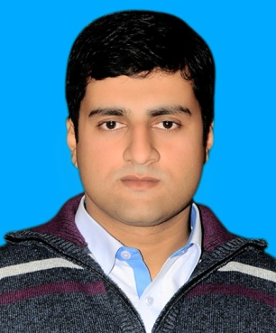

|  |
| --- |
| **Career Objective** |

To put my abilities and learning skills to best use and make my effective contribution to an organization for a bright and rewarding career.

|  |
| --- |
| **Personal Information** |

Father Name : Muhammad Riaz

Date of Birth : 30-7-1986

Address : St#52, H# 21-A, Toheedabad, Quila Lachman Singh, Ravi road, Lahore.

Languages : Urdu, English, Punjabi

Nationality : Pakistani

Domicile : Lahore

N.I.C : 35202-2857433-7

|  |
| --- |
| **Contact Information** |

Email Address : [zeeshan.riaz05@gmail.com](mailto:zeeshan.riaz05@gmail.com)

descent­_dj@yahoo.com

Mobile Phone : 03324278799

|  |
| --- |
| **Education** |

|  |  |  |  |
| --- | --- | --- | --- |
| **Course/Examination** | **Degree** | **Institute** | **Year of Passing** |
| **Masters** | **MBA Finance** | Virtual University of Pakistan | 2014 |
| **Graduation** | **B.COM** | Punjab university Lahore | 2008 |
| **Intermediate** | **I.COM** | Lahore Board | 2006 |
| **Metric** | **Science** | Govt. Central Model School | 2002 |

|  |
| --- |
| **Computer skills** |

**MS. Office** (Word, Excel, PowerPoint), Quick book, Outlook, Internet surfing

|  |
| --- |
| **Personal Skills** |

Great attitude with a high-energy personality, Professional appearance and work ethic, Target driven and self-motivated, Able to work in a highly dynamic environment and able to multi-task, Excellent interpersonal and leadership skills that can motivate people

|  |
| --- |
| **Experience** |

**Accounts Officer**

Currently I am working in Head office of **"Model Steel Group of Companies"** as an **"Accounts Officer"** since 10 years**.**

**Assistant Accounts Officer**

In **"Model Steel Enterprises Private Limited "** I had worked as an “**Assistant Accountant Officer”** for one year.

**Management Trainee Officer**

In “**Black Gold Industry”** a subsidiary company of **"Model Steel Group of Companies"** I had worked at several posts. I worked As "**Internal Auditor"**, "**External Auditor"**, **"Purchase Officer,** and **"Assistant Accounts Officer"**

**Assistant Accountant Officer**

In **"Infinity Engineering Pvt Ltd"** I had worked as an **Assistant Accountant Officer** for less than one year.

**Member of security Management**

I had Worked as "Point commander", Team Leader, as a member of upper security management in the Government Department **"Evacuee Trust Property Board"** (On BS-12) for 9 Months, on contract Basis.

**Internship**

I have completed **internship** in **"MCB Bank"** for one and half Month.

**Teaching Experience**

I had Worked as a **Teacher** in Private school and academy for More than five years.

|  |
| --- |
| **Language** |

Urdu, English, Punjabi.

|  |
| --- |
| **Reference** |

Will be Available on Demand