**OWAIS AYUB**

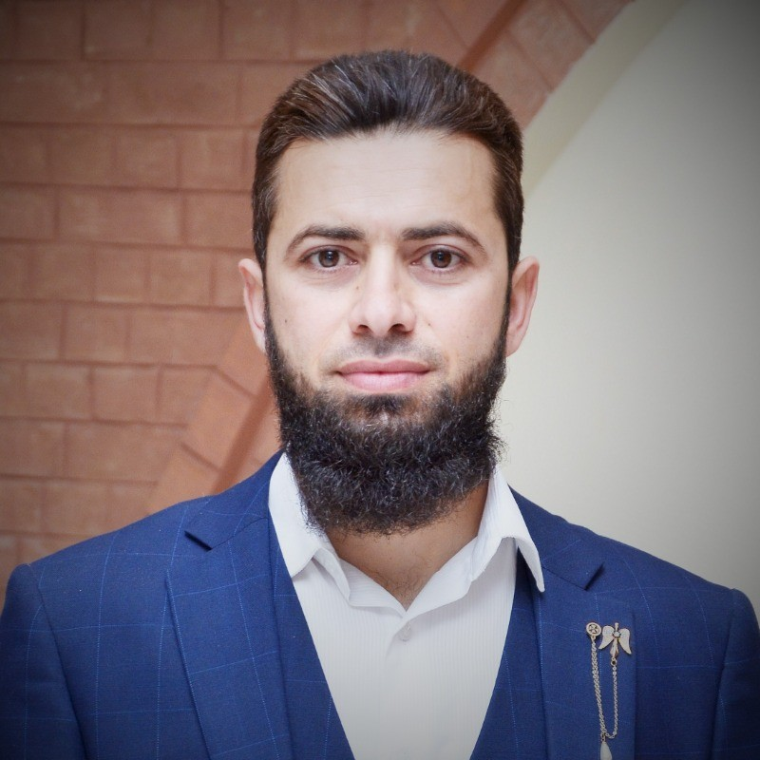

House No 11, Street No 1, Sector H-4, Phase 2, Hayatabad, Peshawar, Pakistan.

Contact: 0345-9420142

E-mail: ovais.ayub1@gmail.com

**OBJECTIVE:**

I want to secure an entrance in an organization that will fully employee my personal skills, my academic training in a rewarding career that affords professional, personal and career growth.

**EDUCATION:**

|  |  |  |  |
| --- | --- | --- | --- |
| **DEGREE** | **YEAR** | **MARKS** | **INSTITUTE** |
| MS Management Sciences | 2020-21 | 74 % | IQRA National University |
| MBA(HR) | 2010-11 | 72 % | CECOS University |
| B.A | 2008-09 | 50 % | Peshawar University |
| FSC | 2007 | 60 % | Edward’s College Peshawar |
| SSC(Metric) | 2004 | 75% | Police Public School Peshawar |

**EXPERIENCES:**

**MANAGER CUSTOMER RELATIONS at TOYOTA FRONTIER MOTORS:   
(From Dec 2016 to Jan 2022) (Approx.5Years)**

Applying Manager Customer Relations functions within organization in the following areas;

* Manages Customer inquiries and answering them via needful information required.
* Handle Customer Complaints and satisfying them via utilizing Good Will fund.
* Maintain the Standard Satisfaction level by resolving Customer complaints and Reporting on daily basis to Head Office and Top Management.
* Responsible for Customer Delight activities within the Dealership.
* Understand, comply & Implement Toyota Global Standards policies at dealership Floor.
* Responsible to build strong collaboration with Head Office (IMC) for implementing New

Projects

* Maintains administrative staff by recruiting, selecting, orienting, and training employees.
* Monitoring and ensuring all Customer related facilities & maintaining the Toyota Global Standards.
* Understand, comply & Implement Toyota Global Standards policies at dealership Floor.
* Maintaining a safe and secure work environment by developing personal growth opportunities.
* Supports operations by supervising staff, planning, organizing, and implementing administrative systems
* Completes special projects by organizing, coordinating information and requirements, planning, arranging, and meeting schedules; monitoring results.
* Supervising day-to-day operations of the administrative department and staff members.
* Developing, reviewing, and improving administrative systems, policies, and procedures.
* Ensuring office is stocked with necessary supplies and all equipment is working and properly maintained.

**ADMIN & HR OFFICER at TOYOTA FRONTIER MOTORS:   
(From Mar 2015 to till Dec 2016) (Approx.2Years)**

* Recruitment, Selection, Hiring & Training Development.
* Maintaining physical and digital personnel records like employment contracts.
* Monitoring Staff attendance & performance.
* EOBI and ESSI management
* Delegating tasks and ensuring that they are completed in accordance with existing policies and procedures.
* Paying Overtime and also managing staff grievances.
* Greeting and directing visitors to the appropriate parties.
* Handling basic office duties, such as answering and routing phones, responding to emails, maintaining employee, financial, and client records, and data entry and reporting.
* Answering questions and finding information for employees, vendors, clients, and lenders.
* Supporting employees by facilitating interdepartmental communications and interactions between internal and external parties.
* Ensuring that the office is well-maintained, organized, and secure.
* Assisting with special projects, such as process improvements and budget development.
* Developing and implementing new policies and processes.

**OFFICE ASSISTANT at PESHAWAR INSTITUTE OF CARDIOLOGY:   
(From Feb 2022 till date) (Approx. 1.8 years)**

* Uploading reports on MIS system.
* Handling incoming calls and other communications.
* Managing filing system.
* Recording information as needed.
* Updating paperwork, maintaining documents, and word processing.
* Performing general office clerical duties.
* Coordinating events as necessary.
* Maintaining supply inventory.
* Maintaining office equipment as needed.
* Creating, maintaining, and entering information into databases.

**ADMIN & HR OFFICER at ICMS EDUCATION SYSTEDM:   
(From Aug 2012 to Oct 2014) (Approx.2Years)**

Applied HR and Admin functions within department in the following areas

* Recruitment, Selection, Hiring & Training Development.
* Maintaining physical and digital personnel records like employment contracts.
* Supports operations by supervising staff, planning, organizing, and implementing administrative systems
* Prepare analysis, record and report asset transactions for financial records.
* Manage recording, summarizing and classifying of assets into different groups.

**INTERN AT UNDP (July 1st 2011 till August 31st 2011);**

During my tenure with National Implementation and Management Unit I assisted Human Resource Officer to develop HRMIS, Recruitment management, Compensation management and Record management. Including:

**COMPUTER SKILLS:**

Proficient in Windows, its applications, MS Office (Ms. Word, Ms Excel, MS. Power point, MS. Access) and internet.

**CERTIFICATES:**

1. **ATTENDED MANAGERIAL TRAININGS:**

All the basic trainings completed at National and international level in Toyota and Implemented Toyota Global standards at Dealership.

1. **ENUMERATOR (UNHCR):**
2. **ANTI NARCOTICS FORCE:**

**LANGUAGE SKILLS**

|  |  |  |  |
| --- | --- | --- | --- |
| LANGUAGE | SPEAKING | READING | WRITING |
| English | Excellent | Excellent | Excellent |
| Farsi | Excellent | Good | Good |
| Pashto | Excellent | Excellent | Good |
| Urdu | Excellent | Excellent | Excellent |

**REFERENCE:**

* Will be furnished upon demand.