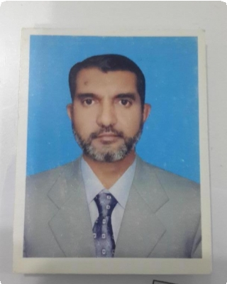Burhan Ali

House No. 285 Street 15 D-2 Supper Market Phase-1 Hayatabad Peshawar

CONTACT

E-mail: [Burhan_sw@yahoo.com](mailto:Burhan_sw@yahoo.com)]

Phone: +925-3339054387]

# WORK EXPERIENCE

## Polyfine Chempharma Pvt Ltd April 1998 — September 2004

**Accountant/Administrative officer**

Main duties performed: book keeping, Trial Balance and import document preparing Payroll and Other administrative matters.

## Cardex Pharma Pvt Ltd October 2004 — December 2004

**Assistant Finance Manager**

Preparation of Books recorded and store supervision.

## Alson Pharmaceuticals May, 2005 — September 2006

**Finance Manager**

Book keeping, Trial Balance and import document preparing Payroll and Other administrative matters.

## Lowitt Pharma Pvt Ltd Oct, 2006 — Till Date

**Manager Finance& Import & Export**

Preparation of all types of Financial reports such as Letter of credit, financial statements reconciliation internal and external purposes, auditing findings. Preparation Report of Inventories, Quick book Enterprise Solution, Sales tax, Income tax Return, all type of government dealings Annual Return Filing (All Corporate documentations of Govtt sector).

# EDUCATION

## Master of Commerce (M.Com) March 1996 — March, 1998

University of Peshawar

## Bachelor of Commerce (B.Com) Jan 1992 — December 1995

University of Peshawar

Diploma in Commerce (D.Com) 1988-1989

Gvot Collage of Commerce of Mardan

# SSC from Govt High School Sawal Dher Mardan 1986