RESUME
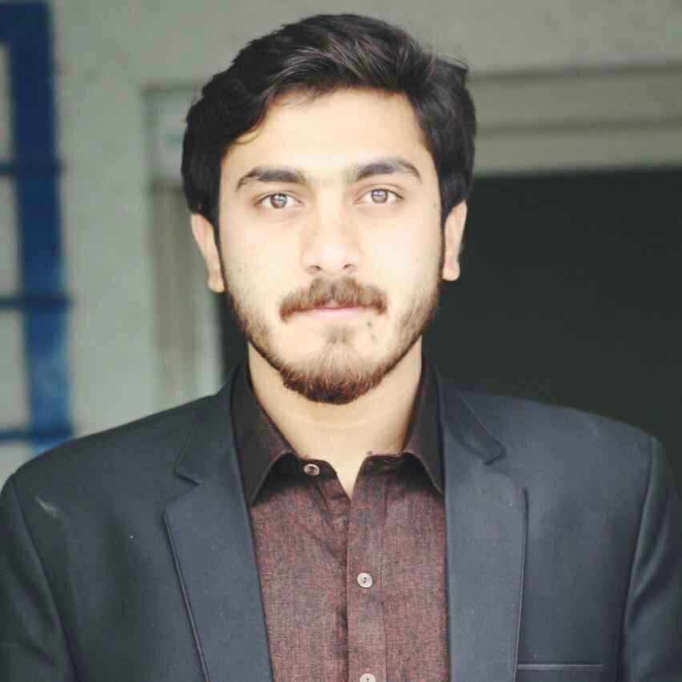 | Bakhtyar Ahmad  Customer Service Officer  CELL: +92 3449090821  Email: bakhtyarahmad93@gmail.com

EXECUTIVE SUMMARY
I am very highly skilled in the field of hospitality and customer service with a track record of success in the Service and hospitality industry with over 5 years of experience.
I have accomplished the responsibilities to the best of my abilities as a hardworking and friendly personality, and aim to acquire a challenging position in the entertainment and hospitality sectors.

PROFESSIONAL EXPERIENCE
Telephone Operator - Customer Service March 2019 - October 2023

Northwest General Hospital & Research Center. Peshawar, Pakistan.

- Completed administrative duties as assigned by the Call Center Supervisor/Coordinator including database entry of on-call schedules, making changes or updates to both hospital and physician office protocols.
- Make outbound customer service calls and provide world-class service in every interaction for optimal call center performance and customer satisfaction.
- Retained significant amounts of information in order to provide the best customer service with the most accurate and helpful information.
- Demonstrated strong attention to detail in accurately documenting customer concerns and resolution of such concerns.

Front Desk Attendant January 2018 - Feb 2019

Luxury Residencia Guest House Peshawar, Pakistan.

- Developed a strong working relationship with co-workers and managers throughout the property to ensure communication and teamwork are at optimum levels.
- Managed reservations and check-ins.

- Performed daily operations of the front desk including checking guests in and out, answering phones and emails.
- Performed other tasks as assigned by the Front Office Manager or Assistant Front Office Manager.

Customer Service & Order Taker. November 2015 - March 2017

Pizza King Fast Food
- Worked as a Customer Service and order taker where my duties were to assist the customers and to provide them with the best options for the food.
- Always delivered my best to customers in a professional way.
- I provided exceptional customer service by taking orders accurately and efficiently. I ensured that customers' needs were met by answering any questions they had and suggesting menu items.
- I also handled cash transactions and maintained a clean and organized work area in creating a positive dining experience for customers.

EDUCATION

University of Peshawar, Pakistan Sep 2015 – Aug 2019 Bachelor in Business Administration (Specialization in HR)
SKILL HIGHLIGHTS
Excellent time management skills Strong interpersonal skills Excellent communication skills Excellent organizational skills Multitasking skills
Computer skills (MS Office) Customer Relations Leadership & competence

