**Profile**

Asif Mushtaque

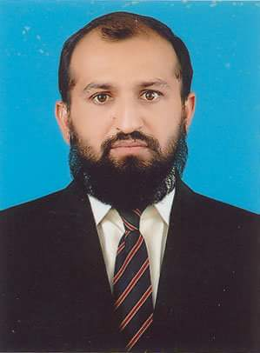

**Address**

Villa No 4059, Precinct 27

Bahria Town Karachi

**Phone**

0092-333-2315975

Email

[asif14397@hotmail.co.uk](mailto:asif14397@hotmail.co.uk)

More than 21 years of experience in Production & planning of steel Making, Project Erection of steel plant, managing Melt Shop Production, including operation AC & DC EAF, Induction Furnace, LF also worked on secondary steel manufacturing ESR, Refractory shop and CCM. Supervise the Hot & Cold Rolling Mills also Certify Quality Engineering Professional by Pakistan institute of Quality Control and worked in integrated steel plants at national and multinational steel organization.

**CAREER ACHIEVEMENTs**

**Education**

MUET Bachelor in

Metallurgical Engineering

**First Class 2nd Position**

**Courses**

**“**Presentation & communication skill” by SZABIST (Job skill Training Center).

“Certified Quality Engineering Professional”

“Energy Management System (EnMS) Implementation”

“Expert Training on Energy System Optimization”

“Project Management Professional”

“MS Office Automation for windows”

MS WORD, MS Excel, MS Power point

**References**

Available on request

**Deputy General Manager Pakistan Engineering Company (PECO)**

**2017 – 2022 Lahore.**

Managing the work in departments to produce structure steel grade for power transmission towers 11, 132, 220 and 500 KVA. Manufacturing of Pumps, Motors, foundry components, Galvanizing and rolling products with reduction cost of heating furnace by coal gasification process also monitoring all the incoming material purchase and finish goods dispatch to end user.

**Senior Engineer Altuwairqi (Arab Steel and National Steel)**

**2008 – 2016 Dammam KSA**

Supervised erection of steel plant which was imported from POSCO South Korea. It included 150T DC EAF,LF, Gas Cleaning plants and six strand billet caster, installation of furnace & related accessories, cold and hot commissioning of plants.

The two process EAF & Induction melting were being tapped in same ladle to enhance liquid weight which reduced cost of production & saves time. Material handling depart facilitated continually DRI and fluxes charge as speed 300 t/h and Refractory shop is equipped with eight ladles with CS- 60 modern slide gate system and seven Tundish with CNC nozzle changer. The production capacity of steel billet 0.8 MTPY.

**Deputy Manager**  **Pakistan Steel Mills**

**2004 – 2008 Karachi**

### Controlling hot rolling furnace with a discharge capacity of 120 tons per hour. Two furnace had been producing 2500 tons of HR Coil per day. High temprature material were rolled by 4 Hi Universal Stand (Reversible), 4Hi Five Stand Intermediate & 4Hi Two Finishing Stand which production capacity 0.6 MTPY. Roll grinding shop facilitated two backup rolling set for smooth production

**Assistant Manager** **Peoples Steel Mills**

**2002 – 2004 Karachi**

Involved in handling Electro slag Re-melting (ESR) steel making process of high quality alloy steel by controlling of PLC base programing. Secondary steel production, we have handled the operation limitation, Refractory behavior, Refining, critical behavior in melting, metallurgical aspects, charge calculation, safety measures, trouble shooting, & managing all things for smooth production of Tool, Die, Stainless and Maraging steels. We also prepared heat treatment cycle of their steel grades.

**Quality Assurance Engineer**  **International Industries ltd (IIL)**

**2000 – 2002 Karachi**

Q.A Engineer successfully monitoring the Inspection, testing & quality assure of steel grate as per international standards & specification. Develops, implements and ensures utilization of Quality methods, procedures and specifications. Monitor the following processing unit slitting, picking, 4Hi cold rolling, Annealing, 2Hi rolling, Mechanical lab and Metallographic testing.