Address:  Universty Town  Peshawar | Contact No  0342-9142825 ashfaqq.khann@gmail.com | 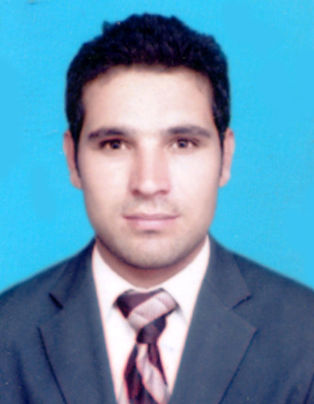
ASHFAQ HASSAN
Value offered:
- I am young, confident and reliable person with full professional communicant. I create a friendly disposition with good sense of humor. I can work well under pressure. Either as an individual or a part of the team. Combined with my dedication. Determination and hard work shall help me to go up the specialist ladder.

Academic And Personal Qualification:

•Graduation SOCIOLOGY (2013) with 46.5%
- Major Subjects: English, Islamic studies, Sociology
Board/University: Abdul Wali Khan University Mardan.

• HSSC D.AE (2011) with 68.9%
- Major Subjects: Project Management, Quantity Surveying, Public Health Engg, Hydraulics & Irrigation, Railway,
Docks , Har & Bridges, Soil mechanics, Highways & Airports, Civil Engineering Project.
Board/University: Board of Technical Education Peshawar.

• SSC Science (2008) with 66.5%
- Major Subjects: Mathematics, Physics, Chemistry, Biology.
Board/University: Board of Intermediate and Secondary Education Peshawar

• Six Months Computer Course (Ms. Office, Ms. Excel, Ms, word)
• Typing Course from Frontier College of I.T Charsa

• Diploma in Fiber Optic (2011) with “A+ Grade”
- Major Subjects: OFC Theory, Tools of OFC, Light Theory, ODF Installation, OFC Jointing, Splicing Machine
Light Sourse, Power Meter, WDM, OTDR Testing, Mechanical Splicing, OFC Connectors,
INSTITUTE: Scientific Skill Training.

Job Experience:

Worked three year experience as a Store Keeper Primer chip board industrial state Peshawar.
Responsibilities:
• Manage system data.
• Responsible all reporting activities related to office.
• Fast and accurate typing skills Data entry and form fillings
• Efficiently and accurately recorded financial and related data
• Take good manner with our Staff.

Data Entry Operator:-
Responsibilities:
• Customer Services
• Fast and accurate typing skills Data entry and form fillings
• Reporting directly and regularly to the Accounting Manager
• Entering accountant and client’s data processing account and customer source documents, maintaining data entry requirements.
• Efficiently and accurately recorded financial and related data.

Personal Profile:
Father’s Name  Date of Birth  C.N.I.C  Passport no  Marital Status  Language Known | Sher Hassan  15th March, 1991  17101-0522236-1  B9988445  Un-married  English, Urdu,  Pashto.

