

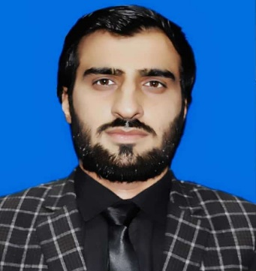

## PERSONAL PROFILE

Date of Birth 23/3/1998

Gender Male

Nationality Pakistan

Religion Islam

Domicile Karak

CNIC 14202-3832379-7

**ADDRESS**

House #597, Street # 8, Sector F5, Phase VI, Hayatabad, Peshawar.

## LANGUAGES KNOWN

English, Urdu, Pashto

**REFERENCE**

**CECOS University Hayatabad Phase VI Peshawar**

Ph: +92-91-5860291-3

Fax: +92-91-5860294

**ARSALAN ADIL**

B.SC CIVIL ENGNEERING

Mob: +923432644406

Email: arsalanadil9@gmail.com

Pakistan, Peshawar

**CAREER OBJECTIVE**

To work in a highly organized and detail-oriented environment to enhance my skills & abilities. I am committed to my work and utilize my skills proficiently to assist organization in pursuit of accomplishing their targets/goals through diligence and hard work.

# EDUCATION

##### [Matric] [Al] Grade Achieved [2011-2013], Qurtuba School and Collage.

##### [Intermediate] [Al] Grade Achieved [2014-2016], Peshawar Model Collage.

##### [B.Sc. Civil Engineering] [Al] Grade Achieved [2016-2020], Cecos University, Peshawar.

##### [M.Sc. Construction Engineering Management] [Al] Grade Achieved [2021-2024], Cecos University, Peshawar.

# SKILLS & COMPUTER PROFICENCY

* Excellent Conceptual and Analytical Skills.
* Leadership, Management of Staff.
* Quantity Surveying, Drawings, Quality of Work.
* Effective Interpersonal Skills.
* **Software skills;** Primavera, Revit, Proficiency in AutoCAD 2D/3D and 3D Max,

Arc GIS, Ms. Office

**EXPERIENCE**

* Currently Working as Field Engineer at NWMC Joint venture by NESPAK and Associated Consulting Engineers on National Program for Improvement of watercourses in Pakistan (NPIWC –II) 19-20 to 23-24.
* Apprenticeship in Program Monitoring unit (PMU), Prime Minister Agriculture Emergency Program, Agriculture Department Khyber Pakhtunkhwa, Peshawar.

**TRAINING COURSES**

* **AutoCAD 2D/3D & 3D Max**

**(03 months)** Training course in Digi Skill LMS, Ministry of Information Technology and Telecom, Government of Pakistan.

* **Primavera**

**(02 months)** Training course of Primavera P6.

* **Revit (04 months)** Training Course of Revit Software

**DECLARATION**

I certify that the above-mentioned information is true to the best of my knowledge and belief.