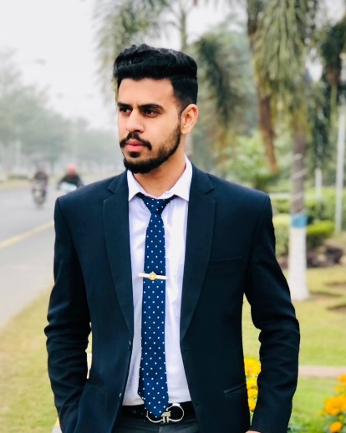 |  | ABDULLAH KHAN
PROFILE  I bring a solid foundation of communication and customer service skills, backed by my educational and professional experience. With a solid experience as a sales executive, I am willing to expand my professional expertise.  Contact  Phone:  0336-5510652  Email: leoabdullah2002@gmail.com  Address:  Village Tarnab Farm & P/O Tarnab Farm Tehsil & District Peshawar |  | EDUCATION  - Secondary School Certificate (SSC)  - Higher Secondary School Certificate (HSSC) from Federal Board of Intermediate and Secondary Education (FBISE)  - BSCS Bachelors in Computer Science  Professional Experience  - 8 months in Nawab Housing as a Team Manager  - 3 months in Akhtar associates as a Sales Executive in Islamabad  - 6 months experience in madina properties Wapda town as Investment Advisor  Language  - English  - Urdu  - Pashto  SKILLS  - Communication  - Customer Focus  - Problem Solving  - Adaptability  - Computer Proficiency

