9

**EXPERIENCE**

**WORK HISTORY;**

* **FEBRUARY-2019 TO MAY-2020**

**(SALMAN BAKERS AND SWEETS)**

* Worked as **Cashier** and **Assistant Manager**.
* Developed business and Client dealing.
* Billings and Accounts.
* **JULY-2020 TO MAY-2021**

**(BRT PESHAWAR)(PRIME-HR)**

* Client dealing.
* Managing software related operations.
* Generating daily cash reports.
* **JULY-2021 TO OCTOBER-2021**

**(TOUCHSTONE COMMUNICATIONS)**

* Worked as **Customer Sales Associate (CSA).**
* Worked as **Customer Service Representative (CSR).**
* Practiced Free lancing.
* Call monitoring and call transcribing.
* Completed daily tasks and Achieved targets.
* Practiced enthusiasm & eagerness to learn new skills with retail sales.
* Focused on maximizing business success by capitalizing on sales and service opportunities.
* **NOVEMBER-2021 TO DECEMBER-2022**

**(COSMETIC EXPERT CLINIC)**

* Worked as **Sales Manager** and **Administrative Assistant.**
* Executed record filing system to improve document organization and management.
* Answered multi-line phone system, routing calls, delivering messages to staff & greeting visitors.
* Restocked supplies and submitted purchase orders to maintain stock levels.
* Generated reports and typed letters in Microsoft Word.
* Scheduled office meetings and client appointments for staff learns.
* Edited documents to improve accuracy of language, flow and readability.
* Monitored office calendars to plan meetings, activities and travel to maximize productivity.
* **JANUARY-2023**

**(TOUCHSTONE COMMUNICATIONS)**

* Worked as **TEAM LEAD OPERATIONS (TL).**
* Focused on maximizing business success by capitalizing on sales and service opportunities.
* Developed Communication skills.
* Experienced team works and Solving different

problems.

* Promoting the Automobile Industry Sales.

Abdullah

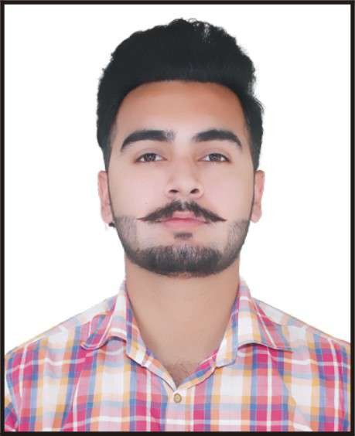

**OBJECTIVE:**

Looking forward to pursue challenging career, which enables me in understanding of organization, And further be part of the solution to the problems. Eagerly involved in continuous learning, upgrading knowledge and skills, looking frequently towards further future growth.

**SOCIAL PROFILES:**

**WHATSAPP :**

# 03110915070

**FACEBOOK:**

AbDuLLAhKhAn

**INSTAGRAM:**

abdullahkhan_7578

**CONTACT:**

🕬 Qazi Gardens, Warsak Road Peshawar, Pakistan

🖶 wmsc7578@gmail.com

🕾 +92 311 0915070

+92 320 9037650

**EDUCATION**

2020 – 2023 **Associate Degree of Computer Science**

CGPA **(3.66/4.0)**

University of Peshawar.

2018 – 2020 **ICs. Computer Science**

Board of Intermediate and Secondary Education Peshawar.

2018 **Matriculation**

Board of Intermediate and Secondary Education Peshawar.

**SKILLS**

* **Computer Fundamentals**
* **Microsoft Office Suite**
* **Sales Marketing**
* **Social Media Marketing Expert**
* **Operating System**
* **Freelancing**
* **Sales Expertise**
* **Interpersonal Communications**
* **Business Development**
* **Sales Strategy Development**
* **Market Analysis and Research**
* **Sales and Promotions**
* **Customer Engagement**

**LANGUAGES**

* **English Excellent ★★★★★**
* **Urdu Excellent ★★★★★**
* **Pashto Excellent ★★★★★**
* **Punjabi Very good ★★★★**
* **Hindko Good ★★★**