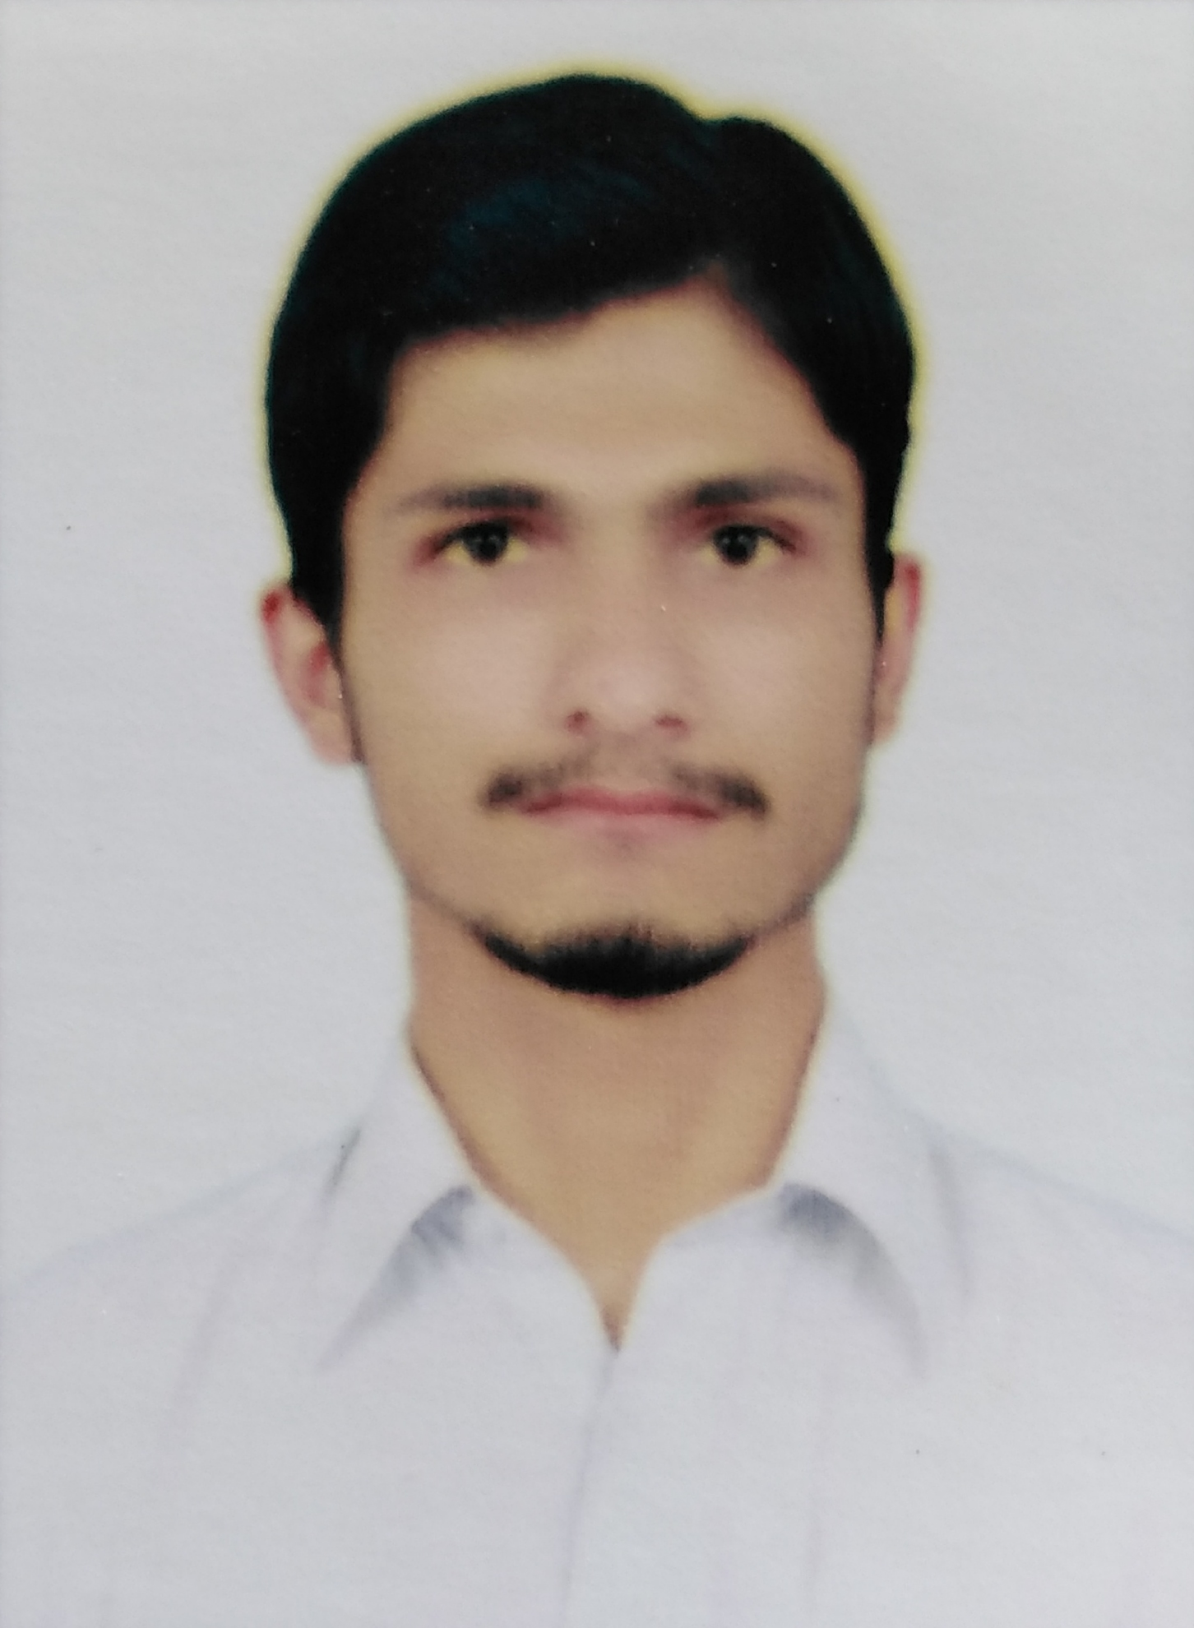

**Abd Ur Rahman**

**AIMS & PROFILE :**To Obtain challenging achievement – oriented position where my abilities and experience will realize their fullest potential with an organization that offers challenge, professional development and reward commensurate with results achieved. **PERSONAL PROFILE :**Father’s Name: Dr.Fida UllahNationality: Pakistani  
Gender: Male  
Religion: Islam  
Mobile No: 03320933289Email : abdurrahmanwazir1997@gmail.com  
D.O.B: 03 April 1998  
Marital Status: Unmarried  
Native language: Pashto  
Domicile: FR Bannu

**Education and Qualification:**

* Matric from BISE Dera Ismail Khan.
* Diploma in Commerce KPBET Peshawar
* BS Accounting And Finance from Brains University phase 3 Hayatabad Peshawar

**Computer knowledge:**

* MS Office
* Accounting softwares
* Data entry

**Personal interest:**

* Administration
* Traveling
* Reading

**Languages:**

**Speaking Writing Reading**

* English: No bad Excellent. Excellent
* Urdu V.Good Excellent Excellent
* Pushto Excellent Excellent Excellent
* Seraiki V.Good Excellent Excellent